DOKUMEN ARSITEKTUR

Finance Portal on Odoo
v2.0 · System of Engagement over SAP S/4HANA · Kafka-Only Integration

Atribut | Keterangan
Dokumen | Architecture Document — Finance Portal (Odoo)
Versi | 2.0
Tanggal | 2026-06-25
DB | Finance Portal DB — baru, terpisah dari existing Odoo DB
Scope | Odoo 19 CE + SAP Bridge microservice (FastAPI + Redis)
Lihat juga | architecture.md (Mermaid) · Project-Charter-Odoo-Finance-Portal.md

1. Architecture Decision Record (ADR)
# | Keputusan | Pilihan | Alasan
ADR-01 | Peran Odoo | System of Engagement (tanpa GL posting) | SAP tetap System of Record
ADR-02 | Database | DB BARU terpisah dari existing Odoo DB | Isolasi lifecycle; tidak ganggu operasional existing
ADR-03 | Multi-PT Erajaya | Single Finance Portal DB + res.company per PT | Consolidated dashboard; shared vendor master; satu SSO
ADR-04 | Integrasi SAP | Kafka-only — Bridge TIDAK boleh call SAP REST langsung | Constraint historis: direct SAP connection tidak disarankan
ADR-05 | Bridge pattern | Kafka consumer/producer + Redis cache + HMAC REST relay | Odoo tidak kenal Kafka; Bridge satu-satunya integration point
ADR-06 | SSO karyawan | Keycloak OIDC via auth_oauth | HRIS maintain employee identity
ADR-07 | Login vendor | Odoo native portal: self-registration + invite | HRIS tidak maintain vendor; vendor bukan employee
ADR-08 | OCR engine | Tesseract 4 LSTM (primary) + pdfplumber (fallback) | CPU-only (VM tanpa GPU); scanned PDF sebagai format utama
ADR-09 | Travel dinas | Read-only mirror dari HRIS | HRIS owns travel engine
ADR-10 | Async push | queue_job with_delay() | Hindari timeout; decouple dari SAP latency

2. System Context
Finance Portal berjalan di Odoo tenant DB baru (finance_portal) pada instance yang sama dengan existing Odoo DB — tidak saling mengganggu. Seluruh komunikasi ke SAP/HRIS hanya melalui Kafka; Bridge tidak pernah call SAP REST langsung.
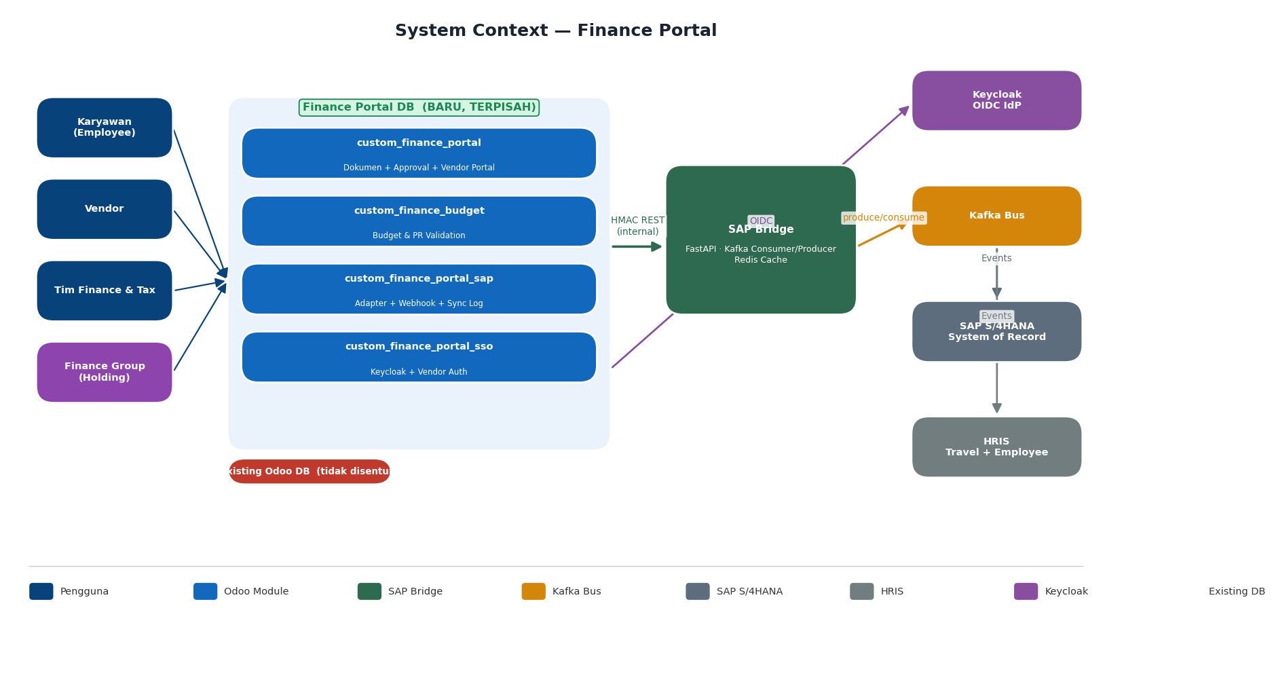
Gambar 1 — System Context: Finance Portal DB terpisah, integrasi Kafka-only.

3. Arsitektur Modul Odoo
Modul | Tanggung Jawab | Depends Utama
custom_finance_portal | Domain engagement inti: semua model dokumen (CA, Reimbursement, Vendor Invoice, Travel), finance.document.mixin, master data, approval Tax->Finance, vendor portal, dashboard, reporting | custom_core, custom_approval_engine, custom_pdp_audit, mail, portal, hr, account
custom_finance_budget | Cost budget per divisi/company/tahun; _check_document_budget() soft/hard; _finance_pr_threshold() resolving limitation | custom_finance_portal
custom_finance_portal_sap | Adapter SAP & HRIS (SapBridgeAdapter, HrisBridgeAdapter); async push via queue_job; cron master sync; inbound webhook secure_endpoint; finance.sync.log + Sync menu | custom_finance_portal, custom_finance_budget, custom_adapter_framework, queue_job
custom_finance_portal_sso | Override _auth_oauth_signin(); vendor self-registration controller (/finance/vendor/register); role → group mapping; auto-provision vendor ke res.partner | custom_finance_portal, auth_oauth, custom_core, auth_jwt

4. Integrasi — Kafka Only (REVISED)
Constraint utama: Bridge TIDAK PERNAH membuka koneksi HTTP/JDBC ke SAP secara langsung. Semua data dari SAP/HRIS masuk via Kafka topics yang di-produce oleh tim SAP/HRIS. Bridge mengkonsumsi semua topics dan menyimpan data di Redis cache. Odoo query Bridge via HMAC REST; Bridge serve dari Redis — SAP tidak perlu expose API apapun.
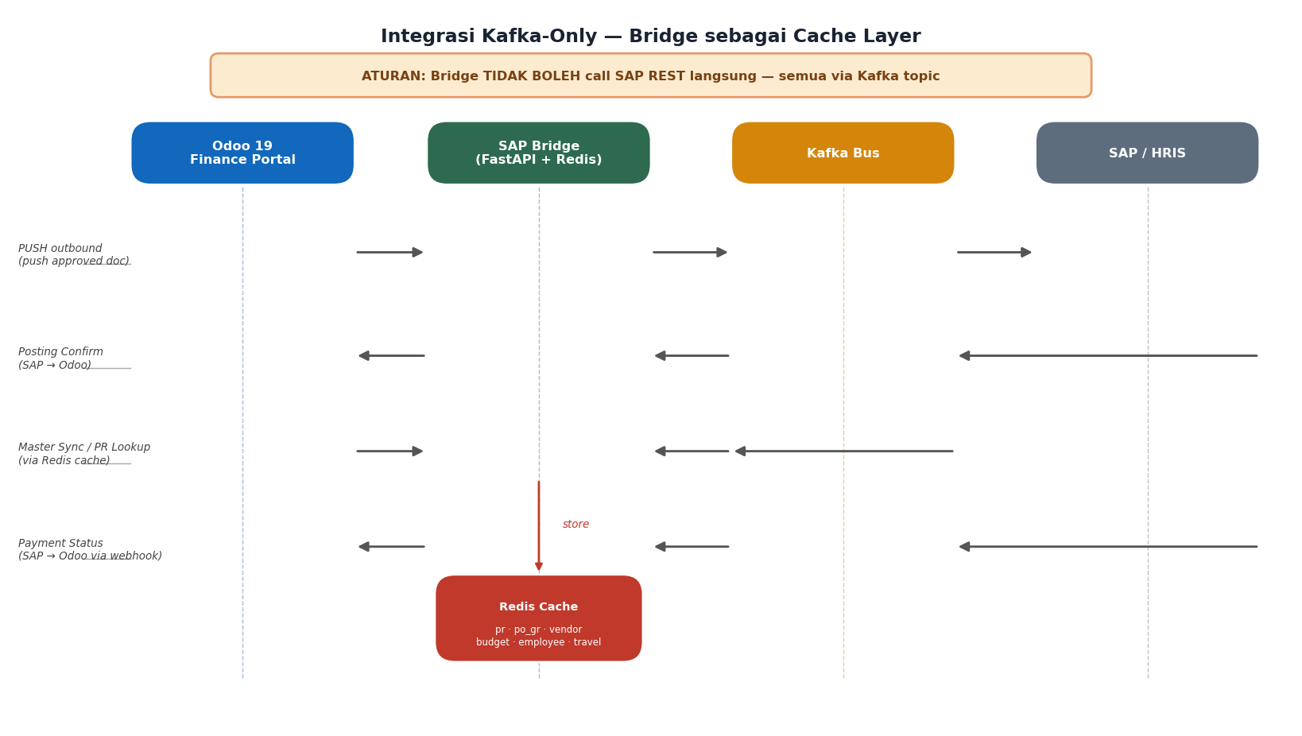
Gambar 2 — Kafka-Only Integration: Bridge sebagai satu-satunya integration hub dengan Redis cache.

4.1 Kafka Topic Map
# | Kafka Topic | Producer | Consumer | Frekuensi
1 | sap.to.portal.pr-master | SAP | Bridge | Event-driven (create/update/close)
2 | sap.to.portal.po-gr-master | SAP | Bridge | Event-driven
3 | sap.to.portal.vendor-master | SAP | Bridge | Daily + on-change
4 | sap.to.portal.budget-master | SAP | Bridge | Daily + on-revision
5 | sap.to.portal.item-category | SAP | Bridge | Weekly
6 | sap.to.portal.bank-master | SAP | Bridge | Weekly
7 | sap.to.portal.payment-status | SAP | Bridge | Event-driven
8 | sap.to.portal.posting-confirm | SAP | Bridge | Event-driven
9 | hris.to.portal.employee-master | HRIS | Bridge | Daily + on-change
10 | hris.to.portal.travel-request | HRIS | Bridge | Event-driven
11 | portal.to.sap.cash-advance | Bridge | SAP | Event-driven
12 | portal.to.sap.reimbursement | Bridge | SAP | Event-driven
13 | portal.to.sap.vendor-invoice | Bridge | SAP | Event-driven
14 | portal.to.sap.travel-settlement | Bridge | SAP | Event-driven

Baris hijau = outbound (Odoo -> SAP). Nama topik, retention, dan partition count disepakati tim Kafka klien.

4.2 PR & PO Lookup via Cache (bukan direct SAP)
Lookup PR/PO tidak lagi memanggil SAP REST. SAP produce PR events ke Kafka secara event-driven; Bridge consume dan simpan di Redis dengan TTL 1 jam. Odoo query Bridge, Bridge serve dari cache.
- Cache HIT: Response instan dari Redis — latensi <50ms
- Cache MISS (PR baru): Bridge return {found: false, retry_after: 30}. UI Odoo tampilkan: 'PR sedang disinkronisasi dari SAP, coba lagi dalam 30 detik'
- Implikasi ke SAP team: SAP harus produce PR events secara event-driven (tidak batch) agar cache selalu fresh. PO/GR sama.

5. Document Lifecycle
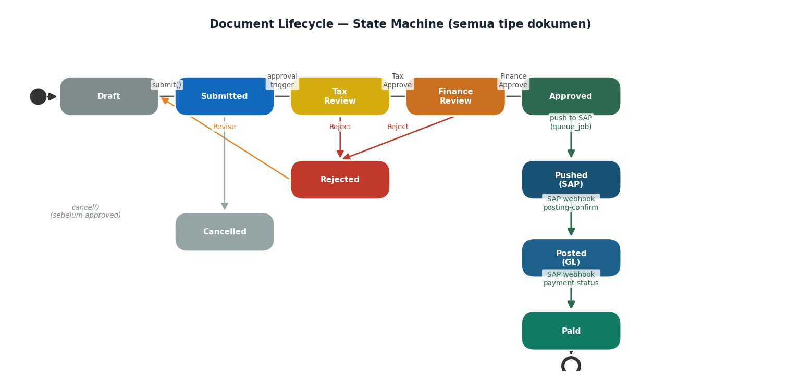
Gambar 3 — State machine berlaku untuk semua tipe dokumen: CA, Reimbursement, Vendor Invoice, Travel Settlement.
State | Siapa yang menggerakkan | Action di Odoo
draft → submitted | Requester (submit()) | Validasi PR threshold + budget check
submitted → tax_review | approval.mixin (tier 1) | Notifikasi Tax Reviewer
tax_review → fin_review | Tax Approver | Notifikasi Finance Reviewer
fin_review → approved | Finance Approver | Dokumen siap di-push
approved → pushed | queue_job worker | _finance_push_to_sap() → Bridge → Kafka → SAP
pushed → posted | SAP webhook (Bridge) | sap_document_no terisi; state = posted
posted → paid | SAP webhook (Bridge) | payment_plan_date + amount terisi; state = paid

6. HMAC Security Model
Canonical message: timestamp.encode() + raw_body_bytes — byte-identical di ketiga titik (Odoo outbound, Bridge inbound, Bridge outbound, Odoo inbound). Drift toleransi +/-300 detik; nonce di-cache untuk cegah replay.
Titik | File | Fungsi
Odoo Outbound | custom_adapter_framework/models/adapter_base.py | BaseAdapter._build_headers(): X-Timestamp + X-Signature
Bridge Inbound | services/finance-sap-bridge/app/hmac_util.py | verify(): canonical ts+body, drift +-300s
Bridge Outbound | services/finance-sap-bridge/app/hmac_util.py | sign(): X-Timestamp + X-Signature
Odoo Inbound | custom_core/controllers/secure_endpoint.py | _verify_hmac(): canonical ts.encode()+raw_body, nonce cache

7. Autentikasi — SSO & Vendor

7.1 Employee SSO (Keycloak OIDC)
- User akses /web/login → Odoo redirect ke Keycloak realm.
- Keycloak: autentikasi (username/password + MFA jika diaktifkan).
- Keycloak kirim id_token + access_token (JWT) ke callback Odoo.
- Odoo _auth_oauth_signin(): verify token via Keycloak JWKS.
- Odoo _finance_sso_apply_roles(): parse realm_access.roles + resource_access.*.roles.
- Additive mapping: group_finance_* += user (tidak pernah revoke).
- Company switcher tersedia jika user punya akses ke beberapa PT.

7.2 Vendor Login — Self-Registration
HRIS tidak maintain data vendor, sehingga vendor menggunakan Odoo native portal authentication (bukan Keycloak SSO). Dua jalur: self-registration dan invite.
Jalur | Flow | Syarat
Self-Registration | Vendor buka /finance/vendor/register → isi nama PT + NPWP + email PIC → sistem match NPWP dengan res.partner dari SAP master sync → Finance admin approve → email aktivasi → vendor set password → login | NPWP harus sudah ada di vendor master SAP (sync Kafka)
Invite (Finance → Vendor) | Finance buka res.partner vendor → klik 'Grant Portal Access' → sistem buat res.users (portal) → kirim email invite → vendor klik link → set password → login | res.partner vendor sudah ada (dari SAP sync)

Jika NPWP tidak ditemukan saat self-registration: tampilkan pesan 'NPWP belum terdaftar sebagai vendor aktif. Hubungi tim Procurement.'

7.3 Role Mapping
Keycloak Role | Odoo Group | Akses
finance_user | group_finance_user | Submit dokumen; lihat milik sendiri
finance_tax | group_finance_tax | Review & approve tier 1 (Tax)
finance_officer | group_finance_officer | Review tier 2; akses semua dokumen
finance_manager | group_finance_manager | Full access + konfigurasi
(Odoo portal) | group_finance_vendor | Vendor Portal: submit invoice + tracking

8. OCR Pipeline
Format utama yang diterima adalah scanned PDF. Tesseract 4 LSTM berjalan di CPU (VM tanpa GPU). Pipeline memiliki quality gate di awal dan confidence scoring di akhir — semua hasil OCR wajib dikonfirmasi vendor sebelum submit.
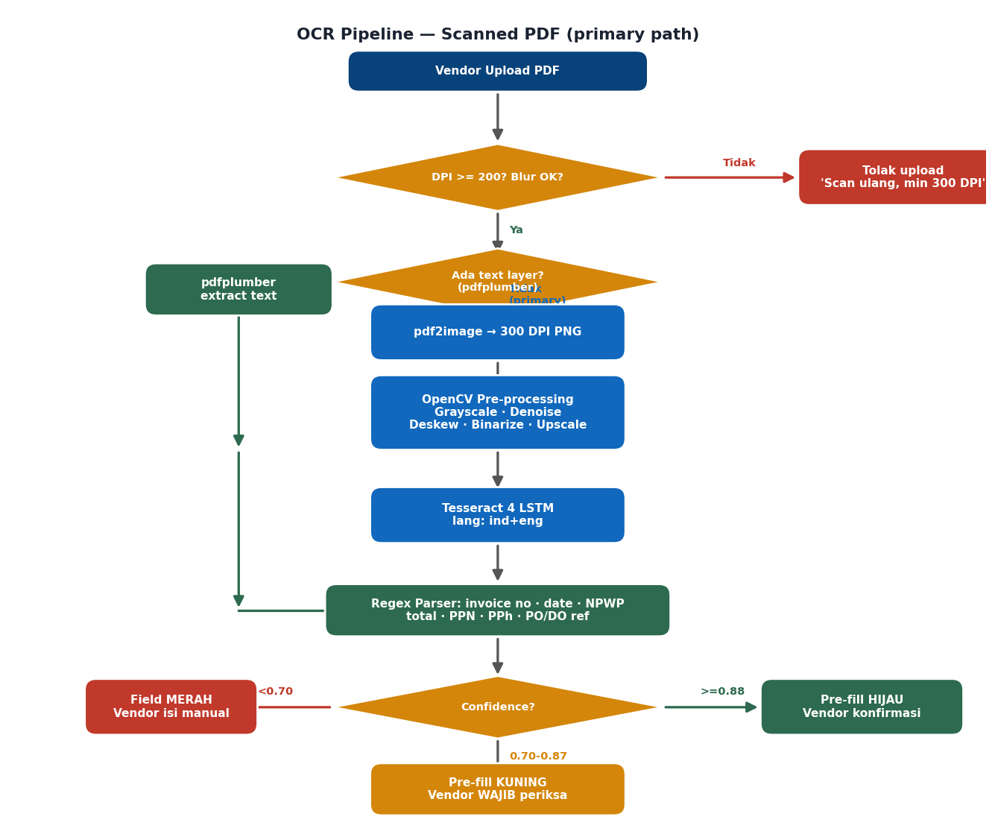
Gambar 4 — OCR Pipeline: Tesseract sebagai primary path; pdfplumber shortcut untuk digital PDF.

8.1 Akurasi Ekspektasi (CPU Tesseract, tanpa GPU)
Kualitas Scan | DPI | Akurasi field numerik | Akurasi tabel/line item
Bersih + datar | >= 300 | 87-90% | 75-82%
Normal, sedikit miring | 200-300 | 78-84% | 65-72%
Buruk / terlipat / stamp | < 200 | 55-68% | 40-55%

8.2 Paket Python (CPU-only, tanpa GPU)
pdfplumber>=0.10 # digital PDF text extraction
pytesseract>=0.3.10 # Tesseract Python binding
tesseract-ocr # system package (apt)
tesseract-ocr-ind # bahasa Indonesia
opencv-python-headless>=4.8 # pre-processing
Pillow>=10
pdf2image>=1.16 # convert image PDF ke PNG
poppler-utils # dependency pdf2image (apt)

8.3 Panduan Upload untuk Vendor
- Format: PDF hasil scan (bukan foto dari kamera HP)
- DPI minimal: 300 DPI
- Warna: hitam-putih / grayscale (lebih bersih dari berwarna)
- Dokumen: rata, tidak terlipat, tidak ada bayangan atau stamp menutupi angka
- Ukuran file: maksimal 10 MB per halaman

9. Multi-Company Architecture
Satu Finance Portal DB berisi res.company untuk setiap PT Erajaya. Isolasi data per PT via company_id pada semua model dokumen, budget, dan approval matrix. Finance Group Manager memiliki akses ke semua PT dalam satu dashboard terpadu.
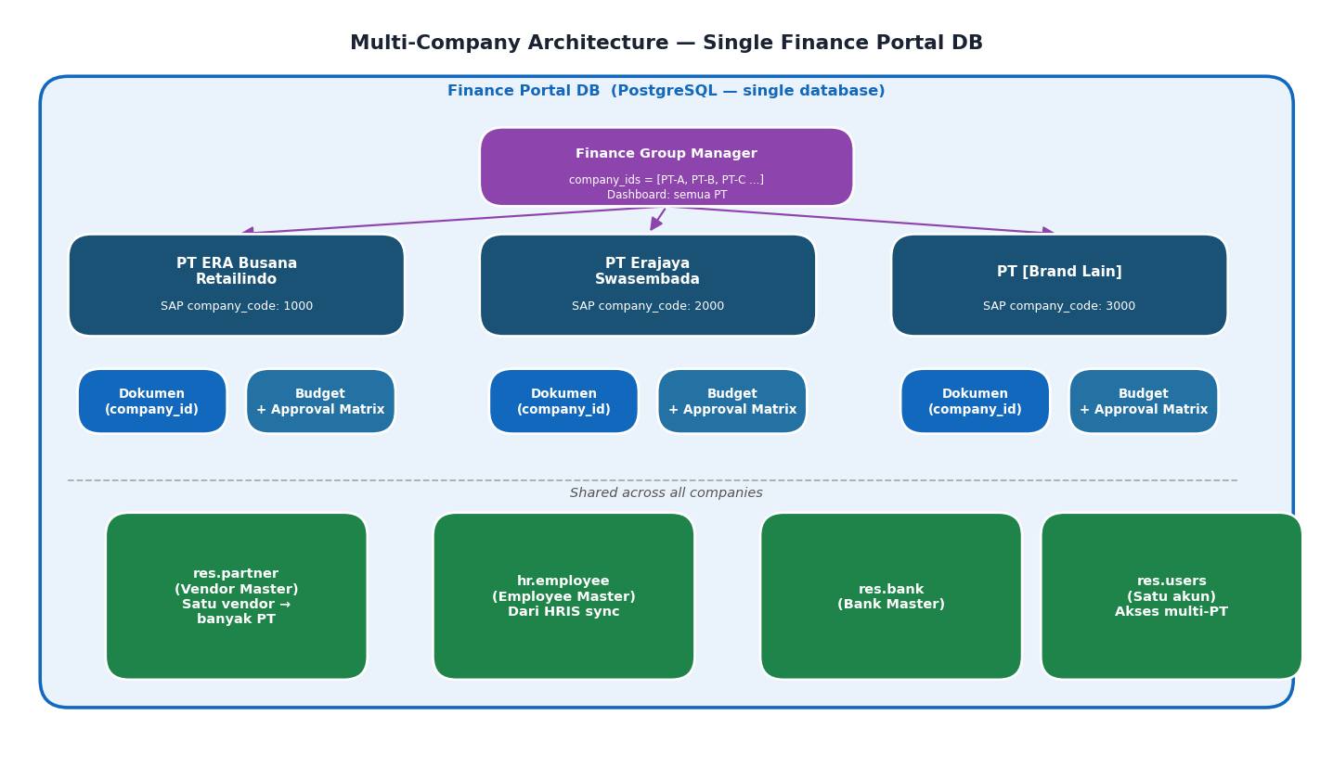
Gambar 5 — Multi-Company: satu DB, company_id per PT, vendor/employee/bank shared.

9.1 Perubahan Teknis di Modul
# Semua model dokumen + budget + approval matrix
company_id = fields.Many2one(
'res.company', required=True,
default=lambda self: self.env.company
)
# Security rule: user hanya lihat dokumen perusahaan yang dia akses
[('company_id', 'in', self.env.user.company_ids.ids)]
# res.company: tambah field SAP company code
x_sap_company_code = fields.Char(string='SAP Company Code')
# Outbound payload ke SAP: sertakan company_code
payload['company_code'] = self.company_id.x_sap_company_code

9.2 User Experience Multi-PT
Role | Akses Company | Behaviour
Karyawan PT A | company_ids = [PT-A] | Submit → company_id = PT-A; company switcher tidak tampil (single company)
Finance Officer PT B | company_ids = [PT-B] | Hanya lihat dokumen PT-B
Finance Group Manager | company_ids = [PT-A, PT-B, PT-C ...] | Dashboard 'All Companies' aggregate semua PT; bisa drill-down per PT
Vendor 'Supplier X' | res.partner (shared, tidak company-specific) | Lihat invoice yang dia submit ke semua PT; pilih 'Tujuan PT' saat submit invoice baru

10. Budget & PR Validation
Langkah | Logic | Konfigurasi
1. Resolve threshold | _finance_pr_threshold(): (1) finance.limitation._resolve_for(doc) best-match submission_type+division; (2) config param custom_finance_portal.pr_required_threshold; (3) default Rp 1.000.000 | finance.limitation master atau config param
2. PR validation (jika amount > threshold) | SapBridgeAdapter.lookup_pr(pr_number) → Bridge Redis → {is_valid, status, remaining_value}. Tolak jika not valid atau status = closed/cancelled | PR data dari Kafka topic sap.to.portal.pr-master (event-driven)
3. Budget check | finance.budget._check_document_budget(doc): hitung consumed dari dokumen in-state submitted→paid; bandingkan dengan total_budget | custom_finance_budget.enforce = False (soft) atau True (hard)

11. Data yang Dikonsumsi Odoo
SEMUA data dari SAP/HRIS masuk ke Odoo melalui: Kafka -> Bridge (Redis cache) -> HMAC REST -> Odoo. Bridge tidak pernah call SAP REST. Odoo tidak pernah call Kafka langsung.

11.1 Master Data SAP (via Kafka -> Redis)
Data Feed | Kafka Topic | Field Wajib | Keterangan
Supplier/Vendor | sap.to.portal.vendor-master | external_id, name, npwp [PDP], bank_account_no [PDP], currency_code, sap_company_codes | Upsert ke res.partner by x_sap_external_id
Division/Cost Center | sap.to.portal.vendor-master | external_id, name, code, company_code | Upsert ke finance.vertical; mapping ke res.company
Cost Budget | sap.to.portal.budget-master | external_id, division_external_id, fiscal_year, total_budget, company_code | Consumed dihitung mandiri oleh Odoo
Item Category | sap.to.portal.item-category | external_id, name, code, is_active | Dropdown baris CA/Reimb/Invoice
Approval Matrix | sap.to.portal.vendor-master | document_type, tier (1=Tax/2=Finance), approver_group | Workaround: konfigurasi manual jika feed tidak ada
Bank Master | sap.to.portal.bank-master | external_id, name, bic, country_code | Ref rekening karyawan; workaround: manual input

11.2 Lookup via Bridge Cache
Lookup | Bridge Endpoint | Field Response Wajib | Behaviour jika Cache MISS
PR Lookup | GET /from-odoo/finance/pr/lookup | is_valid, status (open/partial/closed), total_value, remaining_value, cost_center_external_id | Return {found:false, retry_after:30}; UI tampilkan pesan retry
PO/GR Lookup | GET /from-odoo/finance/po-gr/lookup | po_status, vendor_external_id, total_po_value, items[].unbilled_quantity | Return {found:false}; Finance input manual atau tunggu sync

11.3 Inbound Webhook dari SAP
// Posting Confirmation (state: pushed -> posted)
{"odoo_ref":"CA/2025/00042","sap_document_no":"5100000123",
"sap_posting_date":"2025-01-08","event_type":"posted"}
// Payment Status (state: posted -> paid)
{"odoo_ref":"CA/2025/00042","sap_document_no":"5100000123",
"event_type":"payment_scheduled","payment_plan_date":"2025-01-15",
"payment_amount":3500000.00,"payment_currency":"IDR"}

11.4 Data HRIS
Data Feed | Kafka Topic | Field Wajib [PDP] | Dipakai untuk
Employee Master | hris.to.portal.employee-master | employee_id, email, division_external_id, cost_center_external_id, bank_account_no [PDP], nik [PDP], employment_status | Auto-fill divisi; budget scope; rekening payment
Travel Request | hris.to.portal.travel-request | hris_travel_id, employee_id, purpose, departure_date, return_date, approved_advance, status (approved/travelling), allowance_items[] | finance.travel.settlement; filter status = approved/travelling

11.5 Readiness Tracker
# | Data Feed | Kafka Topic | Frekuensi | Status | Blocker jika Tidak Ada
1 | Supplier/Vendor | sap.to.portal.vendor-master | Daily+change | TBD | Vendor Invoice tidak bisa divalidasi
2 | Division/Cost Center | sap.to.portal.vendor-master | Daily | TBD | Budget check tidak jalan
3 | Cost Budget | sap.to.portal.budget-master | Daily+rev. | TBD | W: soft bypass
4 | Item Category | sap.to.portal.item-category | Weekly | TBD | Dropdown kosong
5 | Approval Matrix | sap.to.portal.vendor-master | Daily | TBD | W: manual config di Odoo
6 | Bank Master | sap.to.portal.bank-master | Weekly | TBD | W: manual input
7 | PR Master (event!) | sap.to.portal.pr-master | Event-driven | TBD | PR validation tidak aktif
8 | PO/GR Master (event!) | sap.to.portal.po-gr-master | Event-driven | TBD | Vendor Invoice PO tidak bisa validasi
9 | Posting Confirm | sap.to.portal.posting-confirm | Event | TBD | State tidak bergerak ke posted
10 | Payment Status | sap.to.portal.payment-status | Event | TBD | Payment tracking tidak update
11 | Employee Master | hris.to.portal.employee-master | Daily+change | TBD | User provisioning manual
12 | Travel Request | hris.to.portal.travel-request | Event | TBD | Travel Settlement tidak bisa dibuat

Kolom Status diisi tim SAP/HRIS klien saat workshop kontrak integrasi (Milestone M1, W3). W = workaround tersedia. Feed #7 dan #8 (PR/PO) WAJIB event-driven — batch harian tidak cukup.

12. Outbound Payloads (Odoo → Bridge → Kafka → SAP)

12.1 Cash Advance GL Posting
{"odoo_ref":"CA/2025/00042","doc_type":"cash_advance","company_code":"1000",
"posting_date":"2025-01-08","employee_id":"EMP-00234",
"cost_center_external_id":"CC-FINANCE-01","currency_code":"IDR",
"total_amount":3500000.00,"pr_number":"PR-2025-00010",
"bank_account_no":"1234567890","bank_name":"BCA",
"lines":[{"item_external_id":"ITEM-001","description":"Tiket","amount":1000000}],
"attachments":[{"filename":"surat_tugas.pdf","content_base64":"..."}]}

12.2 Vendor Invoice MIRO
{"odoo_ref":"INV/2025/00015","doc_type":"vendor_invoice",
"invoice_subtype":"po_non_trade","company_code":"1000",
"vendor_external_id":"V-10001","invoice_date":"2025-01-05",
"vendor_invoice_no":"INV-2024-456","po_number":"PO-2024-00456",
"currency_code":"IDR","amount_net":25000000,"tax_code":"PPh23_2pct",
"tax_amount":500000,"total_amount":24500000,
"cost_center_external_id":"CC-FINANCE-01",
"lines":[{"po_line":1,"gr_number":"GR-2024-00789","quantity":1,"unit_price":25000000}],
"attachments":[{"filename":"invoice.pdf","content_base64":"..."}]}

13. Deployment

13.1 Stack Docker Compose
Container | Port | Keterangan
nginx | 443 (ext) | TLS termination; routing ke finance_portal DB via dbfilter
odoo-app | 8069 (int) | Multi-worker; Finance Portal modules + queue_job worker
odoo-mgmt | 8072 (int) | 1 worker; admin only; share filestore dengan odoo-app
postgres | 5432 (int) | existing_db + finance_portal DB (dua DB, satu instance)
redis | 6379 (int) | queue_job broker
finance-sap-bridge | 8080 (int) | Kafka consumer/producer + Redis cache + HMAC REST
redis (bridge) | 6380 (int) | Redis untuk Bridge cache (terpisah dari queue_job)

PENTING: odoo-app dan odoo-mgmt WAJIB mount volume ./data/odoo-filestore yang sama.

13.2 Urutan Deploy Finance Portal DB
# 1. Buat DB baru
make create-db DB=finance_portal
# 2. Install modul (urutan sesuai depends)
make install MODULE=custom_finance_portal DB=finance_portal
make install MODULE=custom_finance_budget DB=finance_portal
make install MODULE=custom_finance_portal_sap DB=finance_portal
make install MODULE=custom_finance_portal_sso DB=finance_portal
# 3. WAJIB restart (Python tidak re-import dari make update)
docker compose restart odoo-app
# 4. Deploy bridge
docker compose up -d finance-sap-bridge
# 5. Konfigurasi di Odoo Settings:
# - Bridge URL + HMAC secret (dua arah)
# - Keycloak OAuth provider (realm + client_id)
# - res.company per PT + x_sap_company_code
# - Approval matrix per company (tier 1=Tax, tier 2=Finance)
# - Aktifkan cron sync master SAP

14. PDP Compliance
Field | Model | Klasifikasi UU PDP | Perlakuan
nik | hr.employee | Spesifik (Pasal 4) | pdp_class='specific'; masking view non-privileged
bank_account_no | res.partner, hr.employee | Spesifik | Masking 4 digit terakhir; full hanya group_finance_officer+
npwp | res.partner | Spesifik | Masking 6 digit tengah; full hanya group_finance_officer+
Transisi state | finance.document.mixin | — | pdp.audited.mixin → INSERT INTO pdp.audit_log (raw SQL)
Log adapter | custom.adapter.call.log | — | BaseAdapter._sanitize_log() strip field PDP sebelum insert log

15. Ringkasan Komponen
Komponen | Stack | Lokasi | In-Scope
custom_finance_portal | Odoo 19 Python/XML | addons/ee_gap/custom_finance_portal/ | Ya
custom_finance_budget | Odoo 19 Python/XML | addons/ee_gap/custom_finance_budget/ | Ya
custom_finance_portal_sap | Odoo 19 Python/XML | addons/ee_gap/custom_finance_portal_sap/ | Ya
custom_finance_portal_sso | Odoo 19 Python/XML | addons/ee_gap/custom_finance_portal_sso/ | Ya
finance-sap-bridge | FastAPI Py3.12 + Redis | services/finance-sap-bridge/ | Ya (scaffold)
OCR service | pdfplumber + Tesseract + OpenCV | services/ocr-service/ atau inline bridge | Ya
Keycloak | Keycloak 24+ | Infra klien | Tidak
Kafka Cluster + konektor | Confluent / MSK | Infra klien | Tidak
SAP S/4HANA + Kafka producer | ABAP / CPI | Tim SAP klien | Tidak
HRIS + Kafka producer | Vendor HRIS | Tim HC klien | Tidak

